Monitoring Fortified Flour in Country X: An external inspector’s guide to ensuring quality production

Background on the Guide’s Monitoring Recommendations
This document is intended to provide the designated regulatory monitoring authority in Country X (at the time of writing this was the xxx) with guidance on how to effectively assess quality production of fortified wheat flour and compliance with the country’s national wheat flour fortification standards.
The guideline proposes a standardized systems-based approach for determining compliance built upon a foundation of realistic, feasible food fortification standards. This guidance is based on international regulatory monitoring recommendations that were established in 2018 that balance best practices with realistic constraints often faced on-the-ground by food producers and regulatory inspectors. The recommendations reflect consensus among food fortification stakeholders and serve as a resource for those responsible for food fortification policy development and implementation in Country X.
The systems-based approach for monitoring, as recommended in this guideline, is conducted in the context of a comprehensive regulatory monitoring framework as shown in the figure below. For the purposes of this manual, focus is placed on ‘external monitoring’ by government inspectors at production sites.

How to cite this document: Food Fortification Initiative (FFI). Monitoring Fortified Flour in Country X: An external inspector’s guide to ensuring quality production. Atlanta, USA: FFI, 2021. Available from www.FFInetwork.org. Accessed on [date].

Background on Country X’s Fortification Program
Fortification of wheat flour was mandated in X in X by X in order to address high rates of X and X. Nationally, rates of anemia among women are estimated to be X and neural tube defects (birth defects of the spine and brain) are X times higher than what they could be if there was adequate intake of folic acid among women. From an economic perspective, GDP losses as a direct result of vitamin and mineral deficiencies in X are estimated to be over USD X for the country each year
The importance of a strong and functioning regulatory monitoring framework for fortification in the country cannot be underestimated. Simply ensuring a mandatory program is in place is not enough to guarantee that the program will have a positive nutritional impact. The program must ensure that the correct amounts of vitamins and minerals are being added to the food before the effectiveness of the program can be expected or measured. This is the responsibility of both the food producers and government regulatory inspectors. The Recommended Monitoring Protocol and Monitoring Flow Chart (Section I), and the Protocol Implementation Details (Section II) outline a series of streamlined steps to collect critical monitoring information and articulates a process whereby the data can be managed and acted upon so that timely program adjustments can be made.
Section I: Regulatory Monitoring Protocol
Balancing X’s current capacity to conduct timely regulatory inspections of wheat flour production facilities with global best practices, the following protocol is recommended. Details of this protocol are outlined below including an illustration of roles and responsibilities and an explanation of how to implement the protocol in the Monitoring Protocol Flowchart and the Protocol Implementation Details, respectively. In summary, the regulatory monitoring protocol should be as follows:
- Audit-based inspections of wheat flour mills to infer compliance with national standards should happen every time a food safety inspection takes place by X.
- Qualitative and quantitative testing of collected fortified wheat flour samples from mills should happen less frequently than the audit-based inspections and should only be used to verify audit results. Such testing should happen during food safety inpections by X.
- Samples collected for quantitative testing (when they are taken) should be sent to X.
- Following every audit and inspection visit, a final written report should be sent to the respective food producer. Communication of audit results (pass / fail) to mills should take place by X [and include frequency]. Communication of audit results should be take place X days / weeks after collection. Communication of test results, when applicable, should take place two to four weeks after samples are collected. The written report should list the site’s classification – compliant or noncompliant - along with the results of the audit checklist, the qualitative tests, and the quantitative tests (when relevant). Furthermore, it should include recommendations for improvement, any necessary corrective actions, and a timeframe for a follow-up visit (as required).
- All data should then be sent by / to X and stored in X.
Audit and Inspection Responsibilities
The following Ministries and agencies are charged under the law with inspecting fortified wheat flour and ensuring compliance with standards and regulations in Country X:
- X: Responsible for auditing wheat flour production facilities for food safety and fortification quality on the open market.
- X: Responsible for auditing wheat flour production facilities for food safety and fortification quality among mills that provide for the social safety net program.
- X: Responsible for ensuring audit reports are shared with X and collected composite samples are sent to X laboratory.
- X: Responsible for following up with wheat flour millers on non-compliance procedures and implementing non-compliance measures (see Section X).

The flow of information and the breakdown of inspector responsibilities is as follows:
[INSERT Flow chart of monitoring responsibilities]
Section II: Protocol Implementation Details
- Inspection frequency
All producers in the country must be inspected at least [number of times] per year by X inspectors. There may be a different inspection schedules for new facilities, or facilities with reoccurring noncompliance, such as testing once a month for the first three to four months. All inspections must be unannounced.

- Audit-based inspections using checklist found in Annex A
Audit based inspections emphasize the process of fortification over regular testing of fortified food samples. This includes developing an audit checklist that covers food quality, food safety, and food fortification, and that includes premix reconciliation data collection.

The philosophy of the systems-based approach is to control the food manufacturing process appropriately so the end product will – with relative certainty – achieve the necessary food quality, safety, and fortification parameters.

Audits compliment the internal monitoring procedures that food manufacturers regularly implement and track. An overview of audit-based inspections should include the following activities (refer to Annex A for details on how to carry out these activities):
- Inspector will check the raw products before fortification to ensure basic hygiene and Good Manufacturing Practice (GMP) parameters and standards are met.
- Inspector will check for necessary equipment and ingredients for fortification (for example, feeder and premix supply).
  - The fortificant premix should be stored properly (cool, dry place, away from direct sunlight), not expired, adequate amounts are in stock, and Certificate of Analysis (COA) is present and indicates appropriate fortificants and levels according to the national standard for fortification.
- Inspector will observe the fortification process.
- Conduct critical location checks (for example, inside the feeder and inside the premix storage area).
- Confirm that internal monitoring quality assurance and quality control protocols are established and followed.
  - For example, adequate dosing, proper and thorough mixing, proper handling and storage, equipment maintenance.
- Review records that document internal monitoring practices for proper record keeping.
- Conduct a premix reconciliation calculation, to determine whether the fortification process is sufficiently adding micronutrients to the food. This equation compares whether the amount of premix used correlates appropriately to the amount of fortified food produced over a set time period.
- Check labeling of finished product for appropriate labeling as required by regulations. Fortificant levels claimed should be accordance with the levels required by the national standard. For example, manufacturers of processed foods or food products shall include on the label a statement of “nutrition facts” indicating the nutrient(s) and the quantities of said nutrients added in the food. Proper packaging for fortified products includes the use of opaque (where possible) and airtight materials to avoid unnecessary nutrient degradation during transport and storage on the market.
- Product nutrient labelling with usage of the national fortification logo in accordance with the logo guidelines (if relevant)

Annex A contains the recommended checklist that regulatory inspectors should use to assess food safety and fortification quality of food producers. The checklist takes into consideration global best practices and the realities of on-the-ground constraints.

Premix Reconciliation Calculation
The data points needed for the premix reconciliation calculation include: starting premix inventory, amount of premix purchased (if any), ending premix inventory, and the amount of fortified product produced over a specified period of time. The remaining data points are calculated using simple math (see Table 1 below). Food manufacturers should always aim to achieve the target premix addition rate as specified by the premix producer.

Table 1: Premix reconciliation calculation

Item | Unit | Where to Locate
A. Starting inventory of premix | MT | See facility records
B. Amount of premix purchased | MT | See facility records
C. Ending inventory of premix | MT | See facility records
D. Amount of premix used | MT | Calculate: A+B-C
E. Fortified product produced | MT | Facility records
F. Actual premix addition rate | g/MT | Calculate: D/E x 1000
G. Target premix addition rate | g/MT | Provided by premix producer
Result: Percent of target addition rate | % | Calculate: F/G x 100

- Sample collection to verify the presence of added nutrients
The purpose of collecting fortified food samples is to verify the presence of added nutrients. The monitoring protocol should include details on how to collect samples and how many samples to collect. Samples can be measured two ways:

- Qualitative testing – checks for the presence of added nutrients (Yes/No), not the nutrient level. These tests are usually done onsite by the food inspector, with minimal reagents and laboratory skill. Results are immediately available.
- Quantitative testing – checks for the amount of nutrient present in the sample. Usually requires that the sample be sent to a laboratory for analysis. Turnaround for results will depend on where the sample was sent (domestic vs. international lab) and/or capacity at the lab.

The recommendation is to analyze composite samples of fortified foods quantitatively only periodically and as a means to validate the findings of an audit.
Qualitative Testing
Government food inspectors should prioritize rapid qualitative tests, which are low-cost and user-friendly over quantitative testing. These tests confirm that fortified foods contain test-specific vitamins and minerals. Regulatory inspectors should collect samples for qualitative testing each time an audit inspection is conducted. Note that it may not be necessary to collect food samples if the audit based inspection found that the fortification process is not occurring (for example, the necessary equipment or ingredients are not present). Samples for quantitative testing, however, should only occur once per year.

The commonly used rapid qualitative tests for iodine in salt and iron in wheat flour are in Annexes B and C. If a food requires more than one nutrient (such as iron and zinc in wheat flour), it’s common practice to only qualitatively check the presence of one nutrient (typically iron) as a “proxy nutrient” to indicate that the other required nutrients are also present.

These qualitative tests can also function as semi-quantitative analyses when the results are compared to a colorimetric chart. Food manufacturers should conduct qualitative analyses on single samples of fortified product multiple times per day as part of their quality control protocols and the results of these internal quality control analyses should be included in the audit based inspection.

Quantitative Testing
Quantitative testing must be done in a laboratory and can be resource- and time-intensive. For these reasons, analyze composite samples of fortified foods quantitatively only periodically and as a means to validate the findings of an audit and not as a stand-alone method for determining compliance. The monitoring protocol should specify the conditions under which a sample should be sent for quantitative testing. Since laboratories conduct the actual testing, the protocols to conduct the quantitative tests should be with the laboratories carrying out the testing.

Examples of “gold-standard” (most-trusted) quantitative techniques include high performance liquid chromatography to measure folic acid in flour and mass spectrometry to measure iron in flour, among others. The more nutrients that are measured in quantitative testing, the more expensive it will be. Certain nutrients, such as folic acid and B12, are added in very low levels, making quantitative analyses highly variable. Like in qualitative testing, if a food requires more than one nutrient (such as iron and zinc in wheat flour), it’s common practice to quantitatively check the presence of one nutrient (typically iron) as a “proxy nutrient” to indicate that the other required nutrients are also present. Commercial rapid quantitative tests also exist, such as iCheck™ for iron, iodine, and vitamin A.

To maximize the reliability and precision of quantitative test results, food manufacturers, food inspectors, and laboratory technicians should all receive training on proper sample collection, handling, and storage. Laboratories designated to analyze samples of fortified foods should be appropriately staffed and equipped. Laboratory technicians should be competent in performing validated quantitative testing procedures for micronutrients and in interpreting quantitative results. Furthermore, they should adhere to the accepted timeline for reporting results to the inspector (where applicable) and to the relevant government agencies.

Sample Taking Procedures at Production Facilities
Government food inspectors should collect samples of fortified products from the production line and the warehouse to respectively account for product quality at present and product quality over time. The number of samples that should be collected is decided by how confident and reliable the quantitative results are. A total of 12 single samples is recommended, which provides 85% confidence and 85% reliability.
Samples from production line:
- Single samples from the end of the production line (each single sample should be 400-500 grams) should be obtained at 10-minute intervals in order to capture production-based variations. A total of 12 single samples is recommended.
- Next, the inspector should divide each sample into three parts:
  - The first part of each single sample should undergo a qualitative test, ideally onsite by the inspector. After the result is documented, the tested product is thrown away.
  - The second part each single sample should be placed in containers, sealed, and labeled with the following: product name, brand name, facility address, identification code, batch number, and date collected.
    - These samples should remain at the food production site as a reference samples in case third-party evaluation is needed in the future.
  - When quantitative testing has been deemed necessary (for example, once per year): the third part of each single sample should be placed in containers, sealed, and labeled with the following: product name, brand name, facility address, identification code, batch number, and date collected.
    - These samples are for compositing and quantitative analysis by a laboratory.
- Inspectors should follow the same methodology for warehouse samples, except they will collect the samples (or product packages) at random from various parts of the warehouse.

- Determining compliance
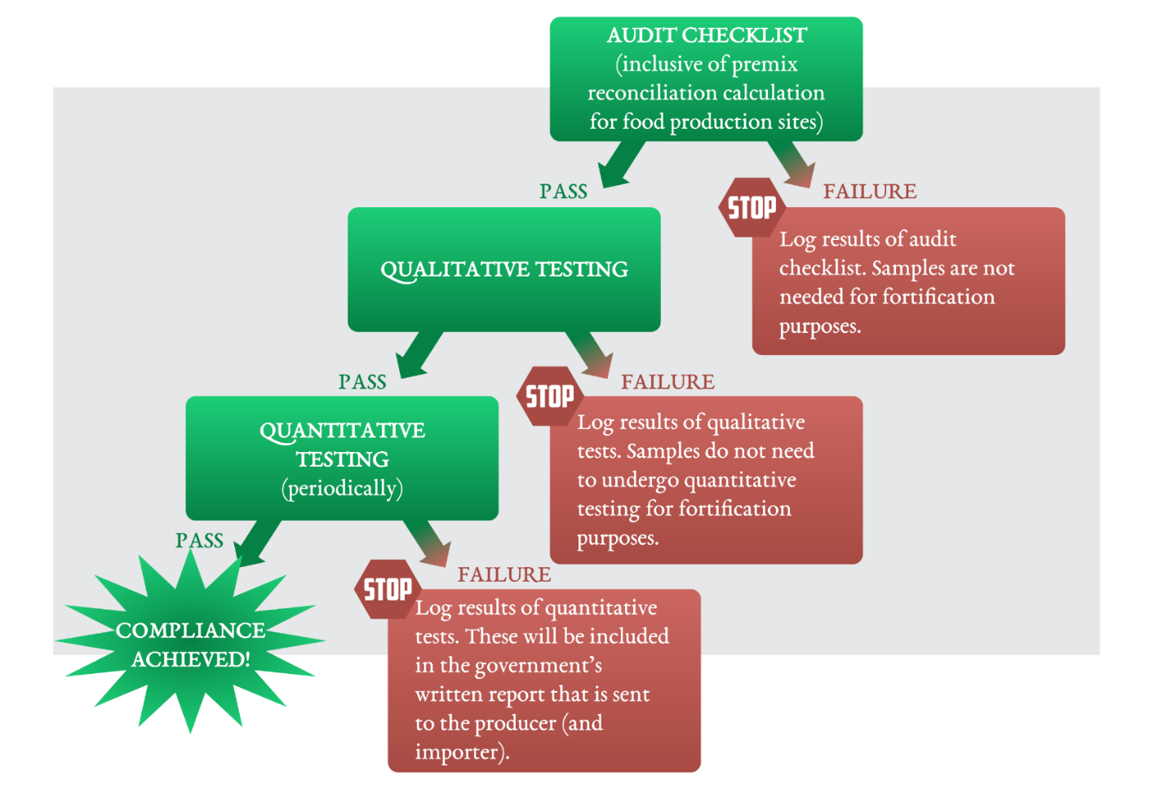
The flowchart in Figure 2 outlines the steps that should be taken in order to determine whether a production facility is compliant with X’s national standards.
Figure 2: Flow chart for fortified food regulatory monitoring
- Compliance measures.
The responsible departments should also have clear protocols for following up with noncompliant food producers. These could include detailed incentives that appeal to the food industry, enforceable penalties that drive consistent compliance among food manufacturers, support or training to ensure that food manufacturers are able to comply in the future, and any modifications to inspection schedules as a result of noncompliance (for example, more frequent inspections or check-ins).

Incentives that appeal to the food industry in addition to meaningful and enforceable penalties that drive consistent compliance among food manufacturers have been adopted and are outlined below.
TBD after discussions with Country X stakeholders
Annex A: Checklist framework – must be adapted by regulatory agencies.

This checklist includes food safety elements. For countries that have an existing checklist, this framework can be used to adapt existing checklists to include food fortification items. The checklist should be designed to help government food inspectors efficiently yet comprehensively review each site’s internal systems and the procedures established to produce high quality, safe, and appropriately fortified foods. In countries where food production sites vary in technological sophistication and size, the checklist will need to account for potential limiting factors at non-industrial facilities while still providing a thorough and appropriate evaluation of the aforementioned categories. Embedding a scoring system into the audit checklist is suggested to facilitate production site compliance determination.

- Food Production Site Operations
Food authority approvals and third-party quality standards
• Operating licenses
• Access control & security
• Food safety and quality certifications (if applicable)

- Food Production Site Design
Appropriate space and functionality for the intended purpose
• Exterior and interior construction and appearance
• Ventilation and temperature
• Production lines
• Storage areas
• Employee workspace and facilities

- Quality Management System
Quality management system established to provide foundation for responsible food production
• System manual
• Internal audit
• Management review
• Non-conformance, corrective actions

- Food Safety
Food safety management tools in operation and working effectively
• Food safety policy
• Food safety team
• Hazard Analysis and Critical Control Points (HACCP)/Good Manufacturing Practices (GMP)
• Critical control points for food safety
• Foreign body
• Glass, metal, and stone
• Metal detection, screens, and sieves utilized
• Microbiological contaminants
• Foodborne toxins
• Hazardous materials
• Cleaning agents, engineering chemicals, pest control materials

- Process Control
Appropriate procedures, work instructions, and records for operational and monitoring activities
• Standard Operating Procedures (SOPs)
• Production records
• Monitoring records

- Fortification
Activities specific to the controlled production of micronutrient-fortified foods

Quality Assurance (QA) activities:
  - Examining the fortificant(s) to ensure that specifications are met.
- Certificate of analysis exists for every delivery of the fortificant(s).
- Check if the fortificant(s) used is still within the market shelf-life.

  - Identifying measures put in place for fortificant(s) handling and storage.
- Fortificant(s) properly sealed and stored in a cool, dry place.
- Sensitive fortificant(s) are in a packing size that can be consumed for one batch of product or for one day’s production.
- Fortificant(s) are properly weighted and appropriate records maintained.
- Weighed fortificant(s) are properly handled; used as soon as possible.
- Container source of the fortificant(s) are immediately sealed after use and stored in a cool dry place.

  - Establishing/Identifying quality assurance on the fortification process.
- The correct equipment is used appropriately for the product being fortified.
- Mixing method as described is an approved production process.
- Mixing time is observed and recorded.

Microingredient feeder/dosifier installation
- The equipment and measuring devices are installed

Microingredient feeder/dosifier calibration
- Conduct equipment calibration
- Equipment and measuring devices calibrated as scheduled.
- Calibration records are maintained.

Premix reconciliation (premix use vs. production output)
- Check premix feed rate
- Refer to Table 1 to conduct reconciliation calculation

Product packaging and labelling
- [Insert details from national labeling regulations]

Quality Control (QC)
- Qualitative testing of the finished product is regularly undertaken and results are consistent
- Quantitative testing results from external laboratories is available (if relevant)

Product recall
- Is there a system for recall in case of product recall is needed?

- Personnel
Items related to defining, screening, monitoring, and developing the workforce
• Job descriptions
• Training schedules and records
• Health checks

- Hygiene
Management of an organized, hygienic, and safe working environment
• Zone control
• Cleaning protocols
• Cross contamination
• Protective clothing
• Housekeeping
• Handwashing
• Human and product waste disposal

- Pest Control
Monitoring and control of specific pests
• Pest entry control
• Pest control within the facility
• Production and storage area observation

- Services
Control of air and water for food production
• Water quality
• Air quality

- Suppliers
Assured raw material and packaging supply lines
• Supplier approval process
• Approved supplier list

- Raw materials
Managing ingredients and packaging
• Receiving and storage
• Clear labelling

- Traceability
Maintaining the identity of all components
• Recall for raw materials

- Warehousing
Appropriate storage of raw materials, packaging, and finished goods
• Raw material acceptance checks
• Raw material release
• Premix certificates of conformity (or analysis)
• Premix storage conditions
• Stock rotation
• Stock labelling
• Rejected & quarantined material handling
• Finished product release criteria

- Maintenance
Ensuring equipment is operating correctly
• Equipment cleanliness and functionality review
• Maintenance plan (internal/external)

- Testing
Raw material, in-process, and finished product analysis
• Internal laboratory testing
• External laboratory testing
• Retained reference samples

- Product Standards
Finished product definition
• Product specifications

Annex B
AACC Method 40-40: IRON-QUALITATIVE METHOD

Scope
Applicable to iron fortified wheat flour.

Reagents
- Thiocyanate reagent. Dissolve 10 g KSCN in 100 ml water. Mix with equal volume of 2N HCl just prior to use.
- Hydrogen peroxide 3%.

Procedure
- Make a flat surface of the enriched flour by pressing down with a flour slick, spoon, the bottom of a small beaker or any suitable smooth surface.
- Drop a few mls of the freshly mixed thiocyanate reagent onto the surface followed by a few mls of the hydrogen peroxide sufficient to wet an area approximately 1 inch in diameter.
- Let stand at least 10 minutes under observation.
- If added iron compounds are present they will show up as red spots on the surface (Figure 1).
- Reduced iron shows up as small dots that take time to appear.
- Ferrous sulfate shows up as larger spots that appear more quickly.
- The density of the spots provides an estimate of how much iron was added, which is best done by comparison to flours having known levels of added iron.

Reagent preparation and storage
The two solutions for the thiocyanate reagent can be prepared in advance and stored in separate bottles as stock solutions. These can be kept for a month. The solutions should be freshly mixed each day to create the thiocyanate reagent. It can be stored for 24 hours.

Ideally all reagents should be kept in an air-conditioned room.

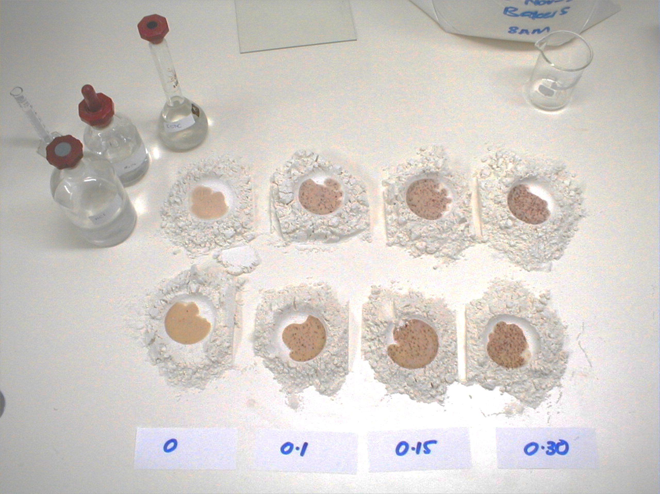
Figure 1: From Left to Right: Samples of fortified flour reacting to the iron spot test. The sample on the far right has reacted for 30 seconds, and the added iron fortificant is visible as dark red spots in the wet flour.

Reference
Schlesinger, H. I., and Van Valkenburgh, H. B. 1931. The structure of ferric thiocyanate and the
thiocyanate test for iron. J. Am. Chem. Soc. 53:1212.

Annex C

Reagents and chemicals
Rapid Test kits (RTKs) for iodate and iodide in salt are commercially available from a variety of suppliers and can be procured through UNICEF, or any other supplier. Use the appropriate one (there is a kit for salt fortified with iodate, and another for iodide).

The test kits have a life span of 18 months but when opened, the solutions are effective for a maximum of 6 months. It is important when using iodine test kits to consider the type of iodine compound (iodate or iodide) that was added to the salt in order to use the correct kit. The use of potassium iodide is discouraged but there could be manufacturers who use it, especially for refined salts, and inspectors need to be aware of this possibility.

Procedure and interpretation
- Place the salt on a clean dry test plate or surface and moisten the salt by dropping the test solution onto the salt.
- If iodine is present in the salt, a blue colour is developed where the solution is dropped.
- If a colour is not developed, add the confirming solution (re-test) over the wet spot (alkaline salts require of this reagent).
- If the blue/purple colour does not appear, it means that the salt lacks iodine from iodate.
- It should be noted that the test kit for iodate will give a negative answer if the salt was iodized with iodide.

Note: Although some kits include a scale of colour to approximate the content of iodine in the salt, do not use it for reporting levels. The kit is unreliable for giving quantitative results; it is only useful for detecting the presence of iodine in salt.

This diagram was adapted from the framework printed on page 179 of the book, Guidelines on Food Fortification with Micronutrients, a publication of the World Health Organization and the Food and Agriculture Organization of the United Nations (2006).
Food safety is an important consideration when assessing facilities that manufacturer fortified foods. A food production facility should not be considered compliant if its system for controlling food safety is not adequately developed or executed.
Metric tons
Grams
Composite samples are comprised of equal parts of multiple single samples (usually at least three) that are collected from the facility.
Composite samples are comprised of equal parts of multiple single samples (usually at least three) that are collected from the facility.
Taking 12 samples is based on the statistical probability (reliability) that 85% of a facility’s production complies with the specifications of the fortification standard and stakeholders can be 85% confident of that assumption.
If a closed-system is used to fortify the product, samples can be collected in the site’s packaging or load-out area.
Alternatively, the inspector can composite the single samples at the food production facility. This will result in one composite reference sample and one composite laboratory sample representing the production line and one composite reference sample and one composite laboratory sample representing the warehouse. This method is easier for government food inspectors because they have fewer samples to keep track of during transportation to the laboratory; just two composite samples instead of 24 single samples. However, if the quantitative results of a composite sample are not compliant with the country’s standard specifications, it will not be feasible to then stratify the composite sample to identify the single samples that actually contributed to the problem. Such information may or may not be important to country stakeholders.
A marker micronutrient is one that is chosen as an indicator for the other micronutrients in the premix. For quantitative assessments, if the analysis demonstrates that the marker micronutrient complies with the relevant standard specifications then the food producers and government food inspectors can surmise that the other added micronutrients will as well.

